Memories & Melodies: Using a Portable Recording Station to Create a Christmas Album with Older Adults at Aged Care Facilities in Auckland
Sam Scott
MA Music Therapy (Distinction), NZ RMTh
Raukatauri Music Therapy Trust
Correspondence: samscottmusic@live.com
Luke Stothart
MMusTher, BMus, NZ RMTh
Raukatauri Music Therapy Trust
Correspondence: lukestothart@gmail.com
Keywords
Music therapy; therapeutic recording; older adults; dementia care; music production
Citation
Scott, S. & Stothart, L. (2025). Memories & melodies: Using a portable recording station to create a Christmas album with older adults at aged care facilities in Auckland. New Zealand Journal of Music Therapy. 23, 61-72.
Review
This article received a single open review.
Abstract
This article presents a practice-based exploration of how two music therapists used sound recording equipment as a therapeutic tool in music therapy sessions across two aged care facilities in Auckland. Over a 10-week period from 4th October to 6th December 2024, sound recording equipment was integrated into music therapy sessions at the facilities with clients recording vocals alongside a range of instruments including guitar, ukulele and percussion. The therapists aim to share their recording process and, by drawing on their reflective practice, offer insights into the psychological benefits observed for clients.

Figure 1
Christmas album cover painted by a volunteer at one of the facilities.

Figure notes: A piece of art created by one of the volunteers at one of the facilities. The artwork is of a gold, red and blue star, situated above the words “The Selwyn Foundation Christmas Album”.
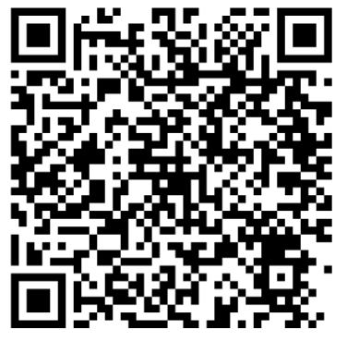
Album link:
https://tiny.cc/fusw001

In July 2023, the Raukatauri Music Therapy Trust received a grant from the New Zealand Community Trust to purchase a portable recording station for use in its music therapy services across Auckland. The recording station included a RØDE NT1-A condenser microphone with shock mount, pop filter, and XLR cable; a Focusrite Scarlett Solo 3rd Gen USB audio interface; Behringer HPM1100 multipurpose headphones; an Alesis V25 MKII USB-MIDI controller; M-AUDIO BX3 studio monitors; a RØDE PSA1 microphone stand; and a STORFEX height-adjustable desk with wheels to ensure accessibility and portability. Although not included in the original grant, an iPad and a Lightning to USB 3 Camera Adapter enabled connectivity between the recording station and the iPad app, GarageBand.
Following the acquisition of the recording equipment, two music therapists from the Trust implemented its use within group music therapy sessions across two aged care facilities. Over a 10‑week period (4 October - 6 December 2024), residents participated in structured sessions involving individuals living with dementia as well as residents without a dementia diagnosis.
During these sessions, the therapists recorded participants performing individually, capturing vocals as well as instrumental contributions on guitar, ukulele, and percussion. The incorporation of recording technology enabled participants to engage more fully in the creative process, while also preserving musical outputs for therapeutic reflection and continuity.
Figure 2
Portable Recording Station at Raukatauri Music Therapy Centre
(Photo credit: Oliver Lowery, 2025)

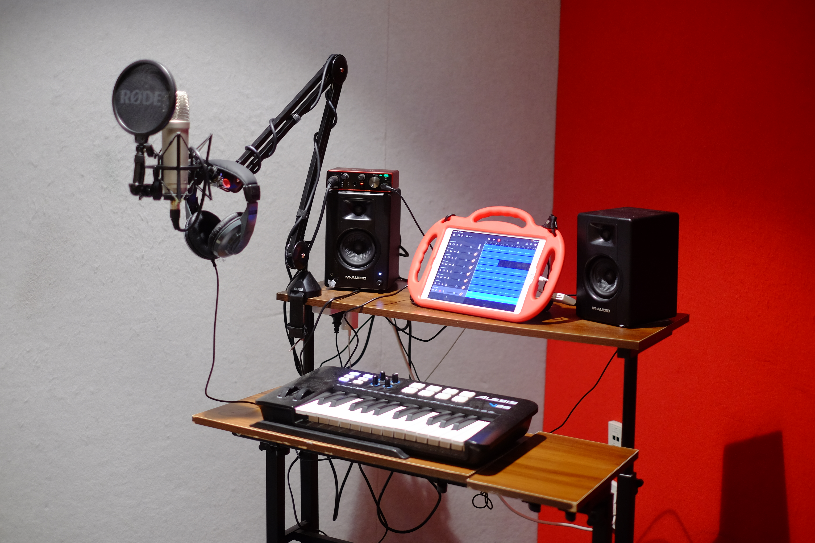
Figure notes: A makeshift portable audio recording station. GarageBand is open on an iPad. There is a microphone and pop filter attached to a moveable desktop stand, stereo headphones, MIDI keyboard, studio monitors and audio interface.
Background
Awareness of the impact of music on older adults has steadily grown over the years. Documentaries such as Alive Inside (Rossato-Bennett, 2014) and Our Dementia Choir (BBC, 2019) have shone a light on the meaningful role music can play for this population, highlighting how music can stimulate memory, improve mood, and support social connection. Furthermore, the documentary Oceania Healthcare – I Love Music (Film Construction, 2017) has helped grow public awareness and understanding of music’s role in aged care within Australasia. In this film, residents were provided with personalised playlists pre-loaded onto MP3 players. The documentary showed that listening to favourite songs from the past, particularly music connected to earlier life experiences, could trigger long-term memories, increase sociability, and enhance emotional wellbeing.
Evidence-based research continues to highlight the significant impact music can have on older adults. Neurologically, music stimulates various areas of the brain, engaging auditory, cognitive, motor, and emotional functions across both cortical and subcortical regions - many of which remain relatively intact with age (Särkämö, 2018). This neural engagement helps explain the wide range of physical and mental health benefits associated with music participation. For example, one study found that listening to upbeat music not only increased emotional arousal but also improved working memory in older adults, suggesting that music can support cognitive function by enhancing mood and alertness (Vincenzi et al., 2022). Additionally, playing musical instruments has been shown to boost fine and gross motor skills, encourage cooperation and focus, and improve mobility, balance, strength, and rhythmic coordination (Thompson et al., 2009).
Historically, the integration of music technology within care home environments has been relatively limited, however in recent times its use has proved beneficial. A pilot study exploring music interventions for people with dementia found that higher levels of engagement with both traditional and technology-based music therapy were associated with significantly reduced agitation and apathy compared to lower levels of use (Dahms et al., 2021). Furthermore, Hebert and Scales (2019) and Thomas et al. (2017) posit flexibility as a key strength of technology-based music therapy, noting that it can be tailored to individual needs and provide autonomous, on-demand access to music, even for those who may not be able or willing to join group sessions. Shah et al. (2024) suggest that incorporating technology into music therapy can unlock new creative pathways, enabling the production of high-quality musical output and further enhancing self-expression.
Weissberger (2014) facilitated a song writing and recording group at a residential and community-based centre for (mostly) over 65-year-olds with varying diagnoses. The author states that, “by using technology in a creative group process we can invite members to experience some of these modern tools and promote inclusion and a sense of belonging” (p. 281). Furthermore, Weissberger (2014) proposed that using GarageBand with adults with physical disabilities helped normalise their surrounding world and kept them engaged. As a result of recording various songs, clients seemed able to “step outside of their illness, if just for a moment, and form new memories while retrieving old ones” (p. 280).
The therapists anticipated that recording vocals and instrumentation with this population would come with various challenges. Veering away from traditional music therapy activities such as spontaneous improvisation and songwriting meant the sessions would be much more structured, making it crucial that the project was underpinned by a reliable and safe relationship between music therapists and clients. Research supports the importance of establishing a therapeutic connection and involving the same music therapist(s) throughout the entire recording process (Grocke et al., 2009; Grocke et al., 2014).
Leading up to the commencement of the project, the therapists had been working in their respective rest home settings for approximately two years. During this time, a relatively low client turnover allowed the therapists to gradually build therapeutic rapport and establish a solid foundation in anticipation of the project’s implementation. Comparable findings are reflected in a study by Silverman (2022), in which the music therapist worked with the participants for four years facilitating songwriting sessions prior to recording their songs. Similarly, the therapists involved in the current study each had over three years of professional experience working with the elderly population, further supporting clinical decision-making and the development of strong therapeutic relationships throughout the project.
Soshensky (2011) highlights the therapeutic and social value of creating permanent artistic products such as CDs, suggesting that a positive aspect of music being part of the entertainment industry is that clients can be perceived as artists engaging in something “culturally idealized” (p. 27). This reframing has the potential to shift perception of people living with disabilities, offering moments where identity can be viewed beyond diagnosis or care needs. Similarly, Sadnovick (2014) introduced a recording studio into music therapy sessions with inpatients at a psychiatric unit, eventually producing CDs at the end of the recording process. Sadnovick (2014) noted that producing a CD was a useful way for clients to connect with friends and family while inside the unit. More recently, Kirkland and Nesbitt (2019) utilised cloud-based storage, allowing clients to access and share recordings produced in music therapy sessions with friends and family. These approaches align with the aims of the current project, which sought to offer clients an opportunity to express themselves creatively while producing something meaningful to share with whānau and wider audiences. In the project at hand, both physical CDs and digital distribution via Bandcamp were used to share the album, making it accessible to family and friends both locally and abroad.
Finally, the therapists sought to assess whether recording could serve as the primary therapeutic focus of a session. Examples of recording being used in this way are rare, as the process is “routinely perceived as a necessary adjunct to facilitating therapeutic programming as opposed to the concept that it has the potential to be a key component to music therapy” (Kirkland & Nesbitt, 2019, p. 5). Furthermore, the authors concluded that, “It may be time to reconsider the voice as a primary instrument in music therapy and to rediscover its benefits and joys through recording.” (p. 7). The current project provided a good opportunity to explore how recording and technology could be integrated as central elements in music therapy sessions.
Summary
Several studies support the use of studio recording in therapeutic settings (Grocke et al., 2009, 2014; Kirkland & Nesbitt, 2019; Sadnovik, 2014; Silverman, 2022; Soshensky, 2011; Weisberger, 2014). While the literature on recording in music therapy is growing, much of it centres on younger populations or community-based projects. To date, there appears to be a lack of research specifically addressing the therapeutic use of recording specifically with older adults in rest home or dementia care settings. Of the literature reviewed, only Weissberger (2014) explored song recording with older adults, albeit in a community-based group with varying diagnoses and cognition levels.
Considering their shared clinical caseloads, one of the therapists in this study, who had previous experience recording adolescent and adult populations in music therapy sessions, determined that producing an album of Christmas songs could be a hugely beneficial project for groups at two separate aged care facilities within the same organisation. The therapists had seen the benefits of music therapy in aged care settings during their daily practice and wanted to work collaboratively towards a project that showcased moments of joy and musical skill while exploring whether recording music in sessions could serve as the focal point of music therapy. Clinical goals included developing client social interaction, building confidence, and increasing comfort with technology, all while creating a celebratory, tangible item for group members and whānau to cherish long-term.

Table 1

Project Procedure Table
Week | Procedure | Details
1 | Project Planning | Define goals, design creative processes, prepare materials (record demo tracks)
2 | Ethics & Consent | Obtain participant consent
3–8 | Recording Sessions | Facilitate and record songs
9 | Mix & Master Music | Edit, mix, and master recorded music ready to be burned
10 | Listening Party | Host a session to share and reflect on the music created / hand out physical CDs

Figure 3
Christmas Album Track List
(Cover credit: Liz Avila. Angel drawn by group member.)

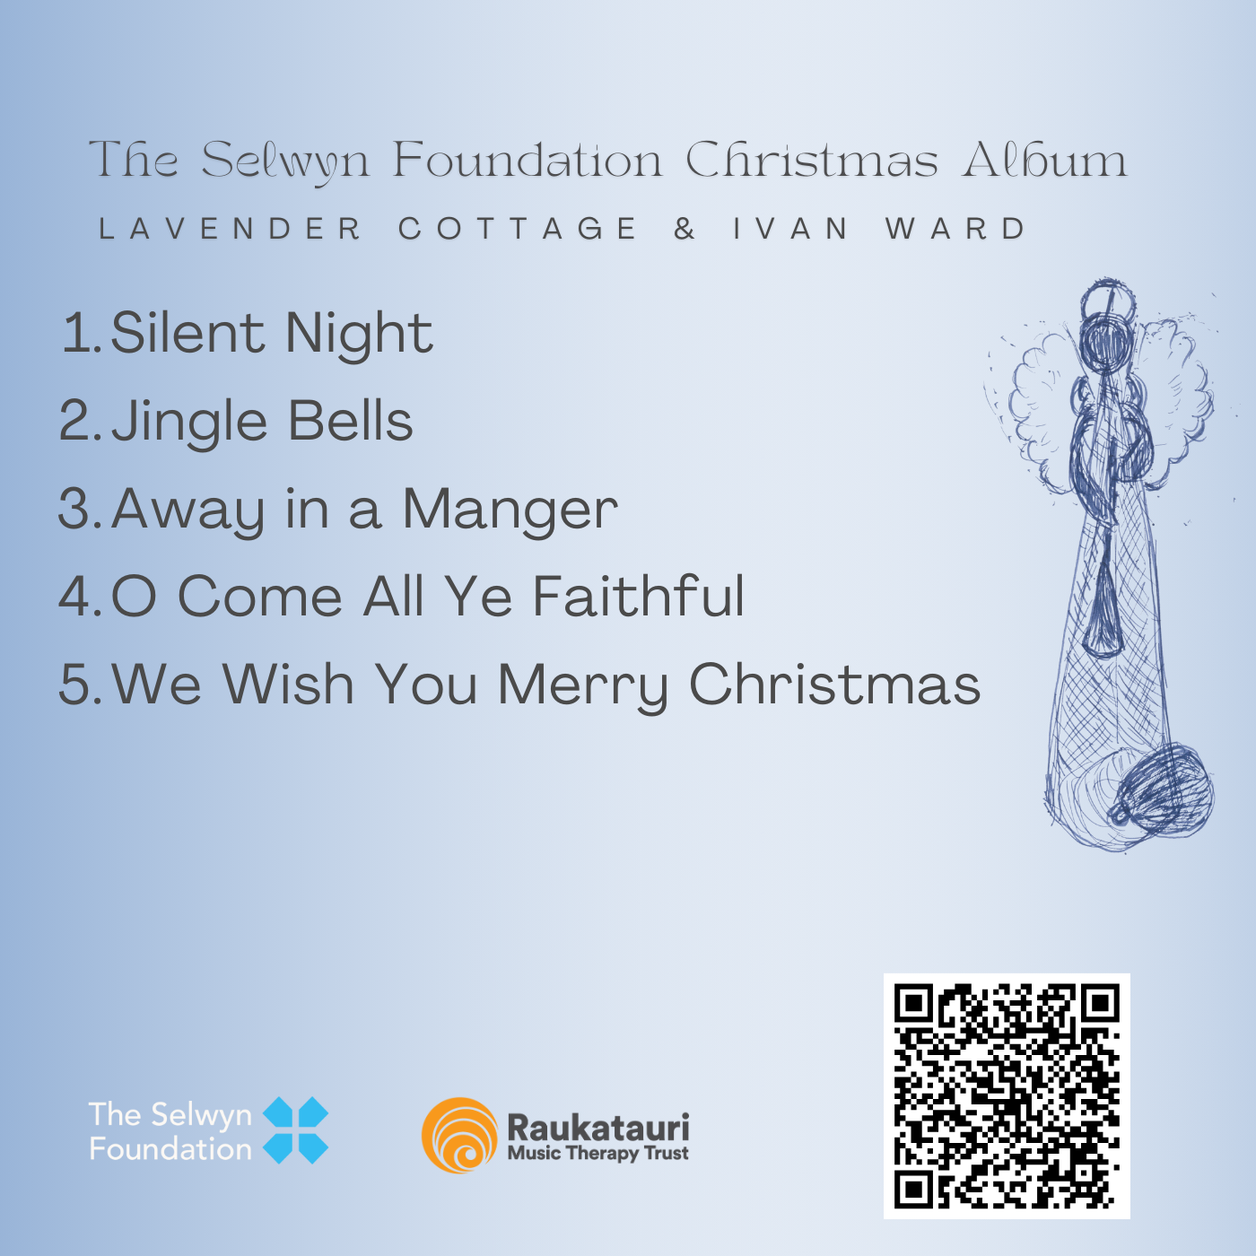
Image description: A track listing for the album, titled “The Selwyn Foundation Christmas Album” and acknowledging “Lavender Cottage & Ivan Ward”. To the right of the track listing is a drawing of an angel. Underneath are logos for the Selwyn Foundation and Raukatauri Music Therapy Trust and a QR code.
Pre-recording
The success of the project relied heavily on clients’ familiarity with the songs. In one facility, due to the intimate nature of the small group setting, the members voted on their recording tracks, with the aim of offering autonomy over the process. Conversely, in the weeks leading up to recording at the other facility, the music therapist catered for a much bigger group by playing a variety of songs and assessing familiarity before choosing the most well-known songs accordingly. The track listing consisted of songs in the public domain such as Silent Night, Jingle Bells, Away in a Manger, O Come All Ye Faithful and We Wish You A Merry Christmas. The therapists acknowledged that Christmas songs are rooted in Christian tradition and express Christian beliefs, which carried the possibility of excluding some individuals. However, there were no objections from the group members, and no one was excluded from participating in the recordings, as the songs selected were either voted for or chosen based on familiarity.
Consent for participation was obtained primarily through signed letters from whānau, with some clients also providing their own signatures. All clients verbally consented prior to the project and again before each recording session. Furthermore, bringing speakers and headphones to each session for recording artists to listen back to their musicianship allowed space for autonomy and governance over recordings. This proved crucial, as some clients chose not to include their recordings in the process after listening back. Members were reminded that they were able to remove themselves from the project at any time.
Permission to publish the album on Bandcamp and share it with potential media outlets, such as radio, was obtained through formal consent letters, and further affirmed through verbal confirmation with residents both during and following the recording process. The album was made freely available for streaming and download, with an optional donation feature. All contributions were directed toward funding new therapeutic initiatives within the facility.
Recording
The two facilities differed in how their sessions were structured; one operated as a day centre for clients, while the other accommodated clients residing there full time. Although many of the clients in both settings had dementia, this was not universal. The clients at the day centre were recorded individually, whereas the clients at the residential facility recorded songs individually in small groups of six.
The therapists aimed to use the recording equipment in the simplest way possible to explore and demonstrate accessibility and ease of use for other music therapists interested in using a recording station with their clients. Tracks were recorded through GarageBand, a free app on the Apple App Store. While the music therapists initially explored live group recording, they decided that recording individual tracks over a pre-recorded demo (with click track) would be most effective, given the individualised needs of the participants. The individually recorded tracks were then layered up and roughly mixed by the therapists. Instruments played by residents on the album ranged from ukulele and guitar to various percussive instruments such as djembe, drums, and shakers.
The therapists agreed that great care needed to be taken during the recording process, both in supporting clients emotionally and in guiding them with the equipment. The music therapists discussed the project with participants, provided a step-by-step explanation of how the recording process would go, and clarified where the recordings would be used when finished. The therapists explained each part of the recording equipment, including microphone and pop shield, and demonstrated how the headphones would be used to help them hear themselves. The therapists also agreed that, if a member seemed unsettled or unhappy, careful attention would be given to explain and settle them, with constant reminders that they could remove themselves at any stage.
When the clients listened back to their own singing and playing, the therapists had not anticipated any negative client response, and upon reflection, they have since seen this as a valuable part of the learning process. When clients did hear their recordings and were unhappy with what they heard, due care was taken to facilitate these emotions and offer opportunities to re-record, play different instruments or remove their recording altogether.
Recording artists who recorded tonal instruments, such as guitar, were the first to record, with other instruments and vocals being recorded later. The therapists, having already built a strong relationship with the members, felt confident in responding to client needs throughout the process. This responsiveness was essential during sensitive moments, such as re-recording sections, encouraging members to increase volume, and generally ensuring emotional and physical comfort.
Flexibility During the Recording Process
In one case, a resident expressed their interest in recording a ukulele part after the instrumental and vocal tracks had already been recorded. They preferred to play in the key of C Major, but the pre-existing recordings were not in this key. To make this possible for them, the entire GarageBand project was transposed to accommodate their preference. From there, the resident was able to record a ukulele part successfully in a key that was achievable for them. Afterward, the project was shifted back to its original key to mix and master. This proved that, despite it being preferable to follow orthodox recording steps, modern music technology allowed for more flexibility when required.

Post-recording
The music was mixed and mastered by the therapists over several sessions. The main goal was to create a mix that was clear, polished, and highlighted the residents' individual abilities at certain points throughout each recording. This was achieved by soloing individual vocal stems throughout a song to showcase their skillset and/or having residents play instruments themselves. During the mixing process, each project was exported from GarageBand on the iPads and imported into Logic Pro X on a personal MacBook Pro owned by one of the therapists. This allowed the therapists to use a more powerful and industry-standard digital audio workstation (DAW), which included valuable stock audio plugins on Logic Pro X (e.g., Chorus, Tremolo, and EQ) as well as several external plugins from Waves V13 (e.g., H-Reverb, H-Compressor, and R-Vox). The two audio plugin engines were used in combination to create clear and polished vocal and instrumental mix chains for each track. During the mastering process, emphasis was placed on ensuring each track was clear across the mix and at a consistent, listenable level throughout the entire album. When reviewing the technical elements of the project, including the recording, mixing and mastering of the songs, both therapists admitted that, without pre-existing knowledge of music technology, additional training may be needed when undertaking projects of a similar scale.
The tracks were burned to compact discs and distributed to group members and whānau. There was a listening party for each facility where the groups listened back to their recordings. Furthermore, clients and whānau were also able to listen to two tracks on the radio when the music therapists were invited to discuss the project on Radio New Zealand.
Outcomes
The therapists observed significant psychological benefits among participants at both facilities. Many members appeared to develop newfound confidence in their musical abilities, which seemed to contribute to enhanced self-esteem and a greater sense of personal accomplishment. The project seemed to foster a noticeable increase in social connection, particularly during the listening parties held at the conclusion of the project. Some members commented positively about their singing and playing and many sang along when listening back to their recordings. The therapists observed many smiles among group members and noticed that they were grateful that they were able to take home a CD. Several months after the release of the album, a participant shared with a therapist during a music therapy session that he had been delighted to have recently rediscovered the CD in his home, showcasing the lasting impact of the project. The therapists finally noted observable benefits for whānau, who were able to experience their family members singing and playing instruments while receiving something they could physically take home and listen to.
Conclusion
The therapists set out to create a Christmas album with group members from two aged care facilities showcasing and celebrating the musical skills of the members involved. They observed that participants displayed a strong sense of accomplishment when sharing their music during the listening parties and became increasingly comfortable with the technology each week. The therapists reflected that the project highlighted how the process of recording music can serve as a central therapeutic focus within music therapy sessions, rather than merely a supplementary activity.
Acknowledgements
Both authors share first authorship and contributed equally to the conception, research, and writing of this article.
References
BBC. (2019). Our dementia choir with Vicky McClure [TV series]. Curve Media; BBC; The Open University. https://www.bbc.co.uk/programmes/m0004pyg
Creech, A. (2019). Using music technology creatively to enrich later-life: A literature review. Frontiers in Psychology, 10, 117. https://doi.org/10.3389/fpsyg.2019.00117
Crowe, B. J., & Rio, R. (2004). Implications of technology in music therapy practice and research for music therapy education: A review of literature. Journal of Music Therapy, 41(4), 282–320. https://doi.org/10.1093/jmt/41.4.282
Dahms, R., Eicher, C., Haesner, M., & Mueller-Werdan, U. (2021). Influence of music therapy and music-based interventions on dementia: A pilot study. Journal of Music Therapy, 58(3), e12–e36. https://doi.org/10.1093/jmt/thab005
Film Construction. (2023, October 10). Oceania Healthcare – I Love Music [Video]. YouTube. https://www.youtube.com/watch?v=1zAJe4XMkWE
Grocke, D. E., Bloch, S., & Castle, D. (2009). The effect of group music therapy on quality of life for participants living with a severe and enduring mental illness. Journal of Music Therapy, 46(2), 90–104. https://doi.org/10.1093/jmt/46.2.90
Grocke, D., Bloch, S., Castle, D., Thompson, G., Newton, R., Stewart, S., & Gold, C. (2014). Group music therapy for severe mental illness: A randomized embedded-experimental mixed methods study. Acta Psychiatrica Scandinavica, 130(2), 144–153. https://doi.org/10.1111/acps.12224
Hebert, C. A., & Scales, K. (2019). Dementia friendly initiatives: A state of the science review. Dementia, 18(5), 1858–1895. https://doi.org/10.1177/1471301217731433
Kirkland, K., & Nesbitt, S. (2019). The therapeutic value of recording in music therapy for adult clients in a concurrent disorders inpatient treatment facility. Voices: A World Forum for Music Therapy, 19(2), 21. https://doi.org/10.15845/voices.v19i2.2636
Rossato-Bennett, M. (Director). (2014). Alive inside: A story of music and memory [Film]. Projector Media. https://www.youtube.com/watch?v=fVkrI1R0XjA
Sadnovik, A. (2014). The birth of a therapeutic recording studio: Addressing the needs of the Hip-Hop Generation on an adult inpatient psychiatric unit. In W. L. Magee (Ed.), Music technology in therapeutic and health settings (pp. 247–261). Jessica Kingsley Publishers.
Särkämö, T. (2018). Cognitive, emotional, and neural benefits of musical leisure activities in aging and neurological rehabilitation: A critical review. Annals of Physical and Rehabilitation Medicine, 61(6), 414–418. https://doi.org/10.1016/j.rehab.2017.03.006
Shah, B., Mukherjee, B., & Sundar, S. (2024). Use of technologies in music therapy clinical practice. SBV Journal of Basic, Clinical and Applied Health Science, 7, 80–95. https://doi.org/10.4103/SBVJ.SBVJ_15_24
Silverman, M. J. (2022). Songwriting, professional studio recording, and a CD release party: Interviews with two adults with mental health conditions. The Arts in Psychotherapy, 79, Article 101915. https://doi.org/10.1016/j.aip.2022.101915
Soshensky, R. (2011). Everybody is a star: Recording, performing, and community music therapy. Music Therapy Perspectives, 29(1), 23–30. https://doi.org/10.1093/mtp/29.1.23
Thomas, K. S., Baier, R., Kosar, C., Ogarek, J., Trepman, A., & Mor, V. (2017). Individualized music program is associated with improved outcomes for U.S. nursing home residents with dementia. The American Journal of Geriatric Psychiatry, 25(9), 931–938. https://doi.org/10.1016/j.jagp.2017.04.008
Thompson, W. F., Graham, P., & Russo, F. A. (2009). Music, thought, and feeling: Understanding the psychology of music. Oxford University Press.
Vincenzi, M., Borella, E., Sella, E., Lima, C. F., De Beni, R., & Schellenberg, E. G. (2022). Music listening, emotion, and cognition in older adults. Brain Sciences, 12(11), 1567. https://doi.org/10.3390/brainsci12111567
Weissberger, A. (2014). Garageband as a digital co-facilitator: Creating and capturing moments with adults and elderly people with chronic health conditions. In W. Magee (Ed.), Music technology in therapeutic and health settings (pp. 279–291). Jessica Kingsley Publishers.

GarageBand is a free digital audio workstation (DAW) used for recording and producing music, available exclusively on Apple devices.

