# Community Voices

# “Comfort like home food”: Gayageum (가야금) in Dunedin

## Hyunah Cho 조현아

PhD, MEd, BA, NZ RMTh, KCMT, FHEA

University of Leeds

Correspondence: [h.cho@leeds.ac.uk](mailto:h.cho@leeds.ac.uk)

### Keywords

Korean immigrants; Korean Kiwis; gayageum; diasporic identity; cultural identity; traditional Korean music

### Citation

Cho, H. (2023). Comfort like home food”: Gayageum (가야금) in Dunedin. *New Zealand Journal of Music Therapy, 21*, 53-66. <https://www.musictherapy.org.nz/journal/2023-2>

### Review

This article received a single open review

## Abstract

This article describes the possibility of the therapeutic use of *gayageum* 가야금 for Korean people in New Zealand. During my time in Dunedin (2016-2022), I performed gayageum music for Korean New Zealanders. Conducting informal interviews, the majority of participants experienced feelings of “comfort”, “relaxation”, and “home”. These findings suggest two conclusions: (1) gayageum music can be a resource for New Zealand music therapy practice with first-generation Korean immigrants; and (2) the possibility of studying the diasporic meaning of gayageum in New Zealand.

## Introduction

Through this article I aim to share the narratives of Korean individuals' journeys in New Zealand. Throughout my six-year stay in New Zealand I had the privilege of being invited to perform the *gayageum* (*가야금*) on various cultural occasions for the Korean community residing in New Zealand. It allowed me to connect with my fellow Koreans, or dongpo[1]동포, and to understand the emotions evoked by the music. I received an impression that the music was giving them a way of finding their own voice; I observed that the gayageum music provided them with a means of discovering their voices. Given my background as both a music therapist and an individual who studied the gayageum, I became increasingly curious about whether gayageum music could serve as a valuable musical resource for Korean individuals seeking music therapy in New Zealand. With this question in mind, I embarked on a journey to explore this possibility, and this article serves as a recounting of that experience.

## Korean Kiwis

According to the 2013 census, Korean immigrants in New Zealand, also known as Korean Kiwis or Korean New Zealanders, are New Zealand’s fourth largest Asian ethnic group, after China, India, and the Philippines (Statistics New Zealand, 2014). Korean Kiwis are a relatively new immigrant group compared to other immigrant groups here (Kim & Agee, 2019). In 2019, New Zealand was the fifth most popular Organisation for Economic Cooperation and Development (OECD) member country for Korean immigrants (OECD, 2021).

As a result of New Zealand's 1987 immigration policy, the number of Korean immigrants has increased through both skilled immigration and investment immigration. Accordingly, the Korean population in New Zealand in 1986 was 369, but 26,434 in 2006, a seventyfold increase (Wallis & New Zealand Department of Labour, 2006). In 2018, they were 35,664 people among 707,598 Asian immigrants (Statistics New Zealand, 2023). Park and Anglem (2012) found that about 70% of Kiwi Koreans lived in the Auckland region and 17% in Canterbury. The 2018 census showed that 70% were still living in the Auckland region, and 10.4% of Koreans in the Canterbury region (Statistics New Zealand, n.d.). Epstein (2006) reported that Koreans who migrated during the wave of immigration were educated, upper-middle class, and relatively wealthy. The main purpose of Koreans moving to New Zealand was to have a new life or to educate their children (Kim & Yoon, 2003; Yoon, 2000). The statistical information and previous studies show that New Zealand may have more Korean immigrants in future.

Korean Kiwis are reported to have unique linguistic and cultural backgrounds (Chang et al., 2006; Epstein, 2006; Park & Anglem, 2012; Statistics New Zealand, 2007). Chang et al. (2006) reported that 89% of Korean New Zealanders are first-generation immigrants who speak only Korean and have a strong attachment to Korean culture. According to Statistics New Zealand (2007), Korean Kiwis use Korean as the primary language within their families, and at least one in three Koreans reported not using English in their daily lives (Statistics New Zealand, 2007). Park and Anglem (2012) reported similar findings and found that Korean Kiwis have a transnational lifestyle, living between their homeland of Korea and their new home in New Zealand. The development of information and communication technologies, such as the internet, increased the transnationality of Koreans.

Korean immigrants in New Zealand feel a significant linguistic and cultural difference, which limits both their participation in social activities in a new environment (Park & Anglem, 2012) and their employment opportunities (Meares, et al., 2010). Moreover, some Korean New Zealanders suffer from cultural and psychological difficulties, acculturation stress, and identity crises due to language difficulties and a lack of family and social support networks (Kim, et al., 2016). Additionally, the conflict caused by cultural differences between first-generation immigrant parents and their 1.5-generation children is another difficulty experienced by Korean New Zealanders (Lee & Keown, 2018). The cultural difference experienced between these parents, familiar with traditional Asian culture, and their children, who have adapted to a new cultural context, was the main cause of family conflict between them (Lee & Keown, 2018). First-generation immigrant parents showed difficulty in adapting to a new culture, while 1.5-generation children experienced confusion and ambiguity about their identity and sometimes faced cultural conflicts (Kim & Agee, 2019).

A further factor is *gireogi appa* (*기러기 아빠*) literally “goose father”. This South Korean term refers to a father who works in Korea while his wife and children stay abroad for their children's education. Families experienced many difficulties when they came to New Zealand to educate their children, while one parent worked in Korea (Lee & Keown, 2018). Goose parents reported physical and psychological exhaustion, due to playing the role of both parents, alone (Lee & Keown, 2018). Despite the need for well-rounded mental health care, support systems which take a culturally sensitive approach are unfortunately scarce (Kulshrestha et al., 2022).

## My Story in New Zealand

I moved from South Korea to Dunedin to study for my PhD in music therapy, and then I became a Korean Kiwi in 2021. Therefore, I am a first-generation immigrant, migrating for the purpose of education. I decided to apply for a New Zealand residence visa for opportunities for my future children's education and a Kiwi lifestyle that appreciates work-life balance.

I engaged closely with Korean Kiwis during my time in New Zealand, and my experiences with them correlated with the above research in terms of their difficulties and transnational lifestyle. Like the people in the research, I lived between New Zealand and Korea. The internet helped me to live this transnational lifestyle. I consumed Korean culture by watching Korean dramas and ordering Korean products. I attended virtual workshops in Korea.

In Dunedin, I performed gayageum for cultural festivals and events and taught Korean and Kiwi children how to play gayageum. Being both a performer and a music therapist, I was more focused on the therapeutic aspects of my playing. I tried to communicate with the audience by inviting them to sing and play other rhythmic instruments (drums, woodblocks, temple blocks, rainsticks, etc.) with the gayageum music. For me, gayageum was a bridge to connect Korea and New Zealand. Through gayageum, I could find my cultural identity by positioning myself between Korea and New Zealand. While playing the traditional Korean instrument, I could celebrate my Korean identity. I felt that I was welcomed with gayageum in this new home that appreciates diversity. The feedback I received after my performances informed me that the Korean audience experienced a similar feeling from listening to my gayageum music. At those moments, I wanted to explore more about their feelings to find the other aspects of gayageum as a potential therapeutic instrument for this specific population.

## Gayageum

The gayageum (Figure 1) is a traditional Korean string instrument that has 12 silk threads, 12 wooden bridges, called *anjok* (안족) – the *goose foot* – which support the threads, and a wooden, resonant box. I have learned gayageum since I was around 11 years old and studied it at university. Although this is a traditional Korean instrument, it was rare to learn gayageum in my childhood, due to its high price and a lack of tutors. I was lucky that my mother was learning gayageum at that time, so I could access the instrument and a tutor. As other Koreans have also described, listening to the gayageum gave me a sense of familiarity and relaxation, even though it was not a common musical instrument at that time. It might be because gayageum music was engraved in my Korean blood, or because I learned the history of gayageum in my school.

The gayageum is the only instrument among the traditional Korean string instruments to have evidence of its origin in Korea in ancient times (Han, 2001). In the chapter *Akji* (악지) in *Samguk-Sagi[2]* (삼국사기) of 1145, it is reported that thegayageum was one of the three representative string instruments, along with the *geomungo* (거문고) and *hyangpipa* 향비파, after the unification by Silla (Encyclopedia of Korean Folk Culture, n.d.). Lee Kyu-bo (1168-1241) of the Goryeo Dynasty left a poem called *加耶琴因風自* (*바람결에 우는 가야금*, *The Gayageum Crying in the Wind*) (Moon, 2015). Two Joseon Dynasty paintings – Kim Heegyeom's 1748 painting *Seokcheon Hanyu* (*석천한유도*) and *Chonggeum Sangryeon (청금산련*) by Shin Yun-bok (1758-?) – show how Korean ancestors enjoyed the gayageum (Moon, 2016).

Later, songs on the theme of the gayageum were popular. For example, the singer Hwang Geum-sim (1921-2001) sang *가야금 열 두 줄* (*Twelve Strings of Gayageum*) and another singer, Kim Yong-im (1965-), sang *열두줄* (*Twelve Strings*). These songs show that the gayageum is deeply rooted for Koreans, both nationally and culturally. The gayageum and its music have become a major factor in the diasporic identity of overseas Koreans (Koo, 2015). Diasporic identity is the collective, ethnic, cultural, and national identities,

Figure 1

Hyunah is playing the gayageum for Korean immigrants in Dunedin

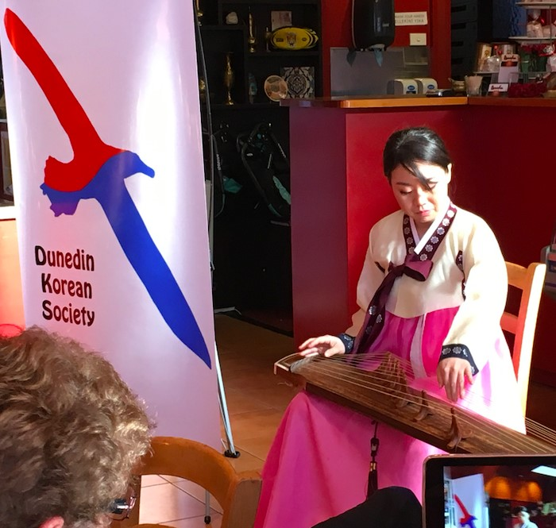

Image description: I sit on a chair, playing gayageum at a Korean community event. While my right hand makes the melody by plucking the strings, the left hand creates resonance and vibration. In this photo, I am wearing hanbok, 한복, the traditional Korean costume.

See an example of gayageum performance:

<https://youtu.be/qEZNEk5fFno?si=BrYVE2xgsH2wZ4s8>

Photo credit: Dunedin Korean Society

(<https://dmec.org.nz/dunedin-korean-society-culture-group>)

as well as transnational migrant identities in a global society (Yim & Kim, 2017; Yoon, 2003).

According to Yoon (2003), Korean immigrants experience isolation in the early stages of migration while undergoing these various diasporic identities, and as they stay longer, they experience accommodation and assimilation. Assimilation was an inevitable survival strategy for Koreans who voluntarily emigrated abroad and became a cultural minority in their new home (Yoon, 2003). However, complete assimilation is impossible, as minority groups are distinguished and differentiated by the dominant majority group (Yoon, 2003). Under these circumstances, Koreans who emigrated abroad tended to choose a strategy of adaptation while maintaining their ethnic and cultural identity (Yoon, 2003). On the contrary, sometimes, third-generation and later Korean immigrants gradually assimilate by marrying people from the dominant majority group and participating in mainstream society (Yoon, 2003). However, as mentioned earlier, the history of Korean immigration in New Zealand is relatively short. Korean Kiwis are first, 1.5, or second generation, and still in the stage of adaptation rather than assimilation.

## The Diasporic Identity of Gayageum

An example of diasporic identity of gayageum is Koo’s (2015) study of the diasporic identity of Korean-Chinese in Yanbian, China and their relationship with gayageum music. During the Japanese colonial period (1910-1945) the Joseonjok 조선족, who migrated from Korea to Yanbian for the independence movement or for work, were a relatively new ethnic group, in comparison with other ethnic minorities in China (Koo, 2015). The gayageum was not well known to the Korean Chinese until the 1950s, after the colonial period. However, three musicians contributed to the establishment of the ethnic and cultural identity of the Korean-Chinese with gayageum music in Yanbian in China (Koo, 2015). Kim Jin (1926-2007) learned *Gayageum Sanjo*, a traditional Korean music genre as well as a specific piece of music, from North Korean musician Ahn Ki-Ok (1894-1974) and introduced this to the Korean-Chinese in Yanbian. Cho Seon-hee (born 1935) improved the 12stringed gayageum to a 23-stringed gayageum during the Chinese Cultural Revolution (1966-1976).

Gayageum music was reformed by integrating the Western and Chinese styles of music (Koo, 2015). Cho Seon-hee tried to have a balance between tradition and modernity (Koo, 2015). Kim Song-sam (1955-present) recreated North Korean music and tried to balance traditional Korean music and new innovative sounds. Since the 1980s, when exchanges between South Korea and China became active, new trends in South Korean gayageum music have also been introduced to Yanbian (Koo, 2015). Consequently, gayageum music for Korean-Chinese differs from South Korean music, which preserves gayageum music as a symbol of national heritage (Koo, 2015). Accordingly, Bakhtin (1981) interpreted Korean-Chinese music as a social phenomenon that emerged as a result of efforts to interact with others and enter the new world, not as a special musical experience for individual musicians (Koo, 2015).

This history shows that gayageum music is a component of diasporic Korean music for Korean-Chinese people. It is a way to provide a space for Korean-Chinese musicians to creatively assert their vision and interpretation of what diasporic Korean music is (Koo, 2015).

## Gayageum in Dunedin

As I was in Dunedin for my PhD, I investigated the emotional response of first-generation Korean immigrants in Dunedin, New Zealand, to gayageum music. I played gayageumfor Korean people in various places at different times. Sometimes, at Korean festivals, I played Korean music, such as the traditional folk songs *Arirang* (*아리랑*, *My Beloved One*) and *Doraji (도라지*, Balloon Flower), and Hwang Byeong-gi's *Soop* 숲 (*Forest*), on the gayageum. At other times, in the community events, such as a Dunedin Art Gallery event, I played gayageum for the Māori waiata *Pōkarekare Ana* or the hymn *Amazing Grace*, and sometimes improvised.

After Korean people had listened to my gayageum music, I received informal verbal comments. I found their responses very precious as they were authentic, genuine, and insightful. Hence, I wrote down what they said and completed a thematic analysis (Terry et al., 2017) to understand both the implicit and explicit meaning of the data (Alhojailan, 2012). The process of thematic analysis in this article was based on my academic training. First, I memoed all the collected data in written form (in Korean), then I translated them into English. The data were thematically colour coded, then I made a thematic map with the emerging themes, to understand the relationships between themes.

As a result, “relaxation”, “comfort”, “cultural identity”, and “home” emerged as key themes. When first-generation Korean immigrants in Dunedin listened to the gayageum music, they felt “relaxation” because the gayageum music and sounds provided “comfort like home food”, “comfort like home”, “comfort from the sound itself”, and a “feeling of relief”. Some people felt “nostalgia” by having a “reminiscence from childhood”. For them, gayageum music connected to their “home”. For some people, the gayageum was a “cultural identity as a Korean” and they could experience “catharsis” through gayageummusic, as it reminded them of their Korean cultural identity and cultural roots. Additionally, some reported that “I want to share this feeling with people from other cultures” and “My body responds instinctively to (gayageum) music”. Figure 2 shows a visualisation of the data; the larger the font size, the more frequently mentioned the words.[3]

## Reflection

My own experience of being a Korean Kiwi and understanding the value of identity and cultural connection widened my scope for emotional expression. There are many possible variables that might induce the audience’s reported emotions. The gayageum playing techniques (i.e. pitch bending, creating feelings of lament) could have fostered emotional expression, capturing the essence of Korean music and preserving the deep cultural meaning of the songs, making the music relatable for the audience. My cultural and musical authenticity could have played a role in providing the wider expressive scope. Despite these variables, this article has provided insight into music therapy practices and studies for the first generation of Korean immigrants.

## Conclusion

I have identified two main points in the findings of my thematic analysis and reflection. These relate to the impact of cultural experiences and the importance of future research.

Firstly, these findings inform us about the available music resources to first-generation Korean immigrants we may encounter in New Zealand music therapy settings. As reported in previous studies, Koreans who are still in the

Image description: A word cloud, displaying word frequency in the author’s thematic analysis. The most common words are relaxation, Korean, cultural, identity, and home. Other, less frequent words are body, catharsis, comfort, culture, feel, feeling, food, hometown, instinctively, music, nostalgia, people, reminisces, sense, share, tone, and want. A colour image is available from https://www.musictherapy.org/journal/2023-2

Figure 2

Word cloud

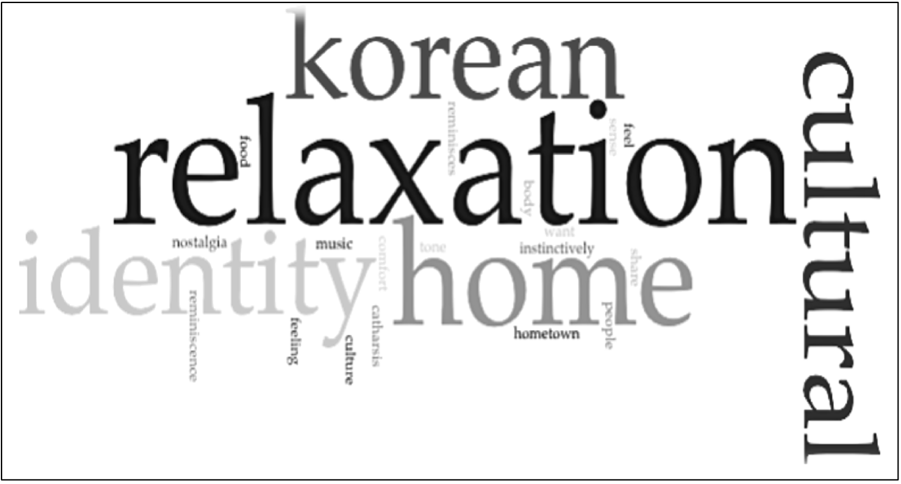-2

stage of adapting to New Zealand's mainstream society, as first-generation or 1.5-generation immigrants, often experience psychological and social difficulties (Kim & Agee, 2019; Lee & Keown, 2018). In addition, the Covid-19 pandemic, beginning in 2019, may have had a negative psychological and social impact on Koreans in New Zealand. In particular, the psychological impact of the coronavirus cannot be ignored for Koreans in New Zealand, a minority group with concerns for their families far away in Korea. In this regard, listening to either live or recorded gayageum music can provide a positive experience for Koreans, which may improve their psychological health.

Providing an opportunity to listen to and talk about gayageum offers people a chance to think about their cultural and ethnic identity as Koreans. This opportunity can help Koreans in New Zealand to develop a variety of identities and provide a psychological connection to their homeland, just as gayageum music did for Korean Chinese in China. While the contexts of these endeavours may differ, the shared experiences related to the gayageum can contribute to identity development, which in turn offers a viable resolution to the parent-child conflicts frequently encountered by Korean immigrants in New Zealand (Kim & Agee, 2018). Listening to or playing gayageum music has the potential to spark conversations about their identities, thereby assisting 1.5-generation Korean immigrants in New Zealand, who often grapple with identity confusion, to discover and reaffirm their cultural identity (Kim & Agee, 2018).

Secondly, it will be meaningful to study the diasporic meaning of gayageum for Koreans in New Zealand in future research. Participants' responses to gayageum listening showed the possibility that gayageum and its music might have a connection with Korean Kiwis’ diasporic identity, either consciously or subconsciously. Studying this topic might provide an understanding of the experiences of Koreans in New Zealand, adding new perspectives and interpretations. In addition, studying the meaning of other traditional Korean instruments for Korean immigrants would be interesting. For example, I found that many Korean communities in different regions in New Zealand have *sa-mul-nor* (사물놀이) groups, which play four different Korean percussion instruments – *buk* (북, a barrel drum), *jang-gu* (장구, an hourglass-shaped drum), *jing* (징, a large gong), and *kkwaenggwari* (꽹과리, a small gong).[4]4 Sa-mul-nori groups play an important role in Korean festivals in New Zealand. Such research would contribute to diversity and inclusion in New Zealand culture by providing an expanded understanding of different cultures.

## Acknowledgements

My sincere appreciation goes to the Dunedin Korean Society, who shared their genuine feelings after listening to gayageum. Also, many thanks to the journal editors, Alison Talmage and May Clulee, for checking my written English and for insightful comments on my draft article. My special thanks go to Angela Ah Young Jeong (정아영), who is also a Korean Kiwi, for reviewing this article by sharing her authentic voice.

## References

Alhojailan, M.I. (2012). Thematic analysis: A critical review of its process and evaluation. *West East Journal of Social Sciences, 1*(1), 39-47. <http://fac.ksu.edu.sa/sites/default/files/ta_thematic_analysis_dr_mohammed_alhojailan.pdf>

Chang, S., Morris, C., & Vokes, R. (2006). *Korean migrant families in Christchurch: Expectations and experiences.* The Families Commission. <https://thehub.swa.govt.nz/resources/korean-migrant-families-in-christchurch-expectations-and-experiences>

Encyclopedia of Korean Folk Culture (n.d.). *Samguk-sagi.* Retrieved October 23, 2023, from <https://folkency.nfm.go.kr/topic/detail/824>

Epstein, S. (2006). Imagining the community: Newspapers, cyberspace and the [non-] construction of Korea-New Zealand identity. In H. Johnson & B. Moloughney (Eds.), *Asia in the making of New Zealand* (pp.147-162). Auckland University Press.

Han, G. (2001). 伽倻琴의 發生 年代에 關한 硏究 (A study on the age of gayageum: Focusing on archaeological data from the ancient age), *Journal of the Society for Korean Traditional Musicology, 2,* 295-306. [https://www.dbpia.co.kr/journal/articleDetail?nodeId=NODE00821477](mailto:https://www.dbpia.co.kr/journal/articleDetail?nodeId=NODE00821477)

Kim, D. & Yoon, H. (2003). Reality in paradise: A pilot study of Korean immigrants in New Zealand using the 1996 census. *The New Geography of Human Mobility-Inequality Trends,* 85-102. <https://www.globility.org/index.php/publication-flyers?layout=edit&id=8>

Kim, H., & Agee, M.N. (2019). “Where are you from?” Identity as a key to parenting by 1.5 generation Korean-New Zealand migrants and implications for counselling. *British Journal of Guidance & Counselling*, *47*(1), 35-49. <https://doi.org/10.1080/03069885.2018.1457770>

Koo, S. (2015). Instrumentalizing tradition? Three kayagum musicians in the People’s Republic of China and the construction of diasporic Korean music. *Asian Music 46*(1), 78-109. <https://www.proquest.com/scholarly-journals/instrumentalizing-tradition-three-kayagum/docview/1640729521/se-2>

Kulshrestha, V., & Shahid, S.M. (2022). Barriers and drivers in mental health services in New Zealand: Current status and future direction. Global Health Promotion, 29(4), 83-86. [https://doi.org/10.1177/17579759221099](https://doi.org/10.1177/17579759221099312)

Lee, B., & Keown, L.J. (2018). Challenges and changes in the parenting experiences of Korean immigrants in New Zealand. *Asian and Pacific Migration Journal*, *27*(4), 431-450.

Meares, C., Ho, E., Peace, R., & Spoonley, P. (2010). *Kimchi networks: Korean employers and employees in Auckland.* Integration of Immigrants Programme, Massey University. <http://hdl.handle.net/2292/8294>

Moon, J. S. (2015). 고려시대 가야금연구 (A study on gayageum during the Goryeo Dynasty.) J*ournal of the Korean Music and Education,* *40*, 7-44. <https://www.dbpia.co.kr/journal/articleDetail?nodeId=NODE06646735>

Moon, J. S. (2016). 조선시대 가야금연구 (Gayageum study in Joseon Dynasty). *Journal of the Korean Music and Educatio*n, *42*, 35-80. [https://www.dbpia.co.kr/journal/articleDetail?nodeId=NODE07102046](mailto:https://www.dbpia.co.kr/journal/articleDetail?nodeId=NODE07102046)

OECD. (2021). *International migration outlook 2021.* [https://www.oecd-ilibrary.org  
/sites/b2ca8b6b-en/index.html?itemId=/content/component/b2ca8b6b-en](https://www.oecd-ilibrary.org/sites/b2ca8b6b-en/index.html?itemId=/content/component/b2ca8b6b-en)

Park, H. J., & Anglem, J. (2012). The “transnationality” of Koreans, Korean families and Korean communities in Aotearoa New Zealand – Implications for social work practice. *Aotearoa New Zealand Social Work*, *24*(1), 31. <https://doi.org/10.11157/anzswj-vol24iss1id139>

Statistics New Zealand. (n.d.). *Korean ethnic group*. Retrieved October 23, 2023, from <https://www.stats.govt.nz/tools/2018-census-ethnic-group-summaries/korean>

Statistics New Zealand. (2007). *Profile of New Zealander responses, ethnicity question, 2006 census.* Statistics New Zealand. <https://thehub.swa.govt.nz/resources/profile-of-new-zealander-responses-ethnicity-question-2006-census>

Statistics New Zealand. (2014). Ethnic group (total responses) by age group and sex, for the census usually resident population count, 2001, 2006, and 2013 censuses. [https://nzdotstat.stats.govt.nz/wbos/Index.aspx?DataSetCode=TABLECODE8021&_ga=2.144515317.1364761207.1560210517-1908992255.1555018022%20#](https://nzdotstat.stats.govt.nz/wbos/Index.aspx?DataSetCode=TABLECODE8021&_ga=2.144515317.1364761207.1560210517-1908992255.1555018022%20)

Terry, G., Hayfield, N., Clarke, V., & Braun, V. (2017). Thematic analysis. In C. Willig (Ed.), *The Sage handbook of qualitative research in psychology* (2nd ed.) (pp.17-37). Sage.

Wallis, R., & New Zealand Department of Labour (2006). *Skilled migrants in New Zealand: a study of settlement outcomes*. New Zealand Department of Labour.

Yim, Y., & Kim, H. (2017). A study on the transnational identity of diaspora and diversity. 한국과 국제사회 *(Korea and Global Affairs)*, *1*(2), 109-128. [https://doi.org/10.22718/kga.2017.1.2.109](mailto:https://doi.org/10.22718/kga.2017.1.2.109)

Yoon, H. (2000). Searching for Korean identity in New Zealand. In D.J. Ball & D.I. Pool (Eds.), *The building blocks of national identity: Population in New Zealand’s history* (pp.63-76). University of Waikato.

Yoon, I. (2003). The Korean diaspora: Migration, adaptation, and identity of overseas Koreans. *한국사회학 (Korean Journal of Sociology)*, *37*(4), 101-142. <https://www.dbpia.co.kr/Journal/articleDetail?nodeId=NODE00890220>

**Appendix A:**

**Word List for Figure 2**

The following keywords are included in the Figure 1 word cloud. Numbers in brackets indicate keyword frequency: some keywords with similar meanings to others were slightly modified to emphasise frequency of the concept.

##### Higher frequency words

Relaxation

Korean

Home

Cultural

Identity

##### Lower frequency words

Body

Catharsis

Comfort

Culture

Feeling

Food

Hometown

Instinctively

Music

Nostalgia

People

Reminiscence

Sense

Share

Tone

Want

1. *Dongpo* refers to overseas Korean groups, emphasising the ethnic links between Koreans.
2. *Samguk-Sagi* (*History of Three Kingdoms*) is a historical record of the Three Old Kingdoms of Korea: Goguryeo (고구려), Baekje (백제), and Silla (신라).
3. For accessibility, a word list from this word cloud is provided in Appendix A.
4. 4 This video shows an example of sa-mul-nori: <https://youtu.be/J35vH40_gsc>