**NEW ZEALAND MUSIC THERAPY**

**REGISTRATION BOARD**

*Established 2000*

**APPLICATION FOR RENEWAL OF ANNUAL PRACTISING CERTIFICATE**

|  |  |
| --- | --- |
| 1. Please read the instructions at the end of this form before completing each section.  **2. Download and save this document before inserting information. Send completed and signed application to:**  registrar@musictherapy.org.nz  3. The application must be completed electronically in order to give the applicant sufficient space to answer questions thoroughly.  4. If this is not possible, then return by post the application form, fee and attachments to: NZMT Registration Board, P O Box 19319, Avondale, Auckland 1746, New Zealand.  5. Please check the MThNZ website for details of the current fee. | |
| **Current Status**: (mark with a cross “x”)  **Full Registration** **Provisional Registration** Year 1 / Year 2 (delete one) | |
| Registration number |  |

**SECTION ONE**

|  |  |
| --- | --- |
| **PERSONAL DETAILS** | |
| First name or given names  *(to be used on certificate)* |  |
| Preferred name if different |  |
| Surname |  |
| Full Home address  Including post code |  |
| Postal address (if different) |  |
| Preferred Email Address |  |
| Telephone |  |
| Current MThNZ member? | YES / NO *(please delete one) This is* ***not*** *the registration fee* |
| Please list any other professional affiliations |  |

|  |  |  |  |  |
| --- | --- | --- | --- | --- |
| **MUSIC THERAPY PRACTICE SINCE ISSUING OF CURRENT PRACTISING CERTIFICATE**  **(See Note 2)** This may include your role as a supervisor or similar role if relevant. Insert additional rows if needed. | | | | |
| **Position** | **Employer details/ Self-employed** | **Type of work/ Population Group** | **Music Therapy Hours/week** | **Date from / to** |
|  |  |  |  |  |
|  |  |  |  |  |
|  |  |  |  |  |
|  |  |  |  |  |
|  |  |  |  |  |
|  |  |  |  |  |

**Total hours per week**

**If fully registered move to Section 3**

|  |
| --- |
| **SECTION TWO**  **Provisionally Registered Music Therapist:** To be completed when applying to **move to full registration**.  Please answer all questions. |
| 1. In relation to the time you have been provisionally registered please provide a reflection and supporting brief example of how you have incorporated each of these areas of the standards of practice into your music therapy practice. If any area has not been incorporated or addressed then please provide an explanation as to why they have not been addressed and a brief outline as to how you may seek to address/incorporate these areas into your practice in the future. |
| * ***Implementation of practice*** *– Please provide a reflection and brief example/s on how you have incorporated aspects, such as musical skills; therapeutic relationship; theory; assessment; implementation and evaluation; or communication, into your practice.* |
| * ***Cultural competence*** *– Please provide a reflection and brief example/s on how you have incorporated this area into your practice. If this is an area which you think needs more consideration in your practice moving forward, please provide an outline as to how you may address this.* |
| * ***Ethical and legal practice*** *– Please provide a reflection and brief example/s on how you have incorporated this area into your practice. If this is an area which you think needs more consideration in your practice moving forward, please provide an outline as to how you may address this.* |
| * ***Reflective practice and continuing professional development*** *– Please provide a reflection and brief example/s on how you have incorporated this area into your practice. If this is an area which you think needs more consideration in your practice moving forward, please provide an outline as to how you may address this.* |

**SECTION THREE**

**CONTINUING PROFESSIONAL DEVELOPMENT RECORD**

For further guidance on how to complete this section please refer to Information Sheet IS1, Registration, Continuing Professional Development and Supervision (please see website: https://www.musictherapy.org.nz/about-mthnz/registration-board/

**2.1 DEFINITIONS OF CATEGORIES FOR CPD RECORD**

|  |  |  |  |
| --- | --- | --- | --- |
| **Code** | **Type of CPD** | **Total CPD hours** | **Examples** |
| 1 | **Music Therapy Specific Training and Development** | 12 hours  minimum | * Attendance at music therapy workshops, seminars or courses (please only note those hours dedicated to professional training, not networking or informal contact) * Music therapy conference presentations and participation * Reading and research that provides the knowledge foundation for the establishment of new initiatives or strategic development of music therapy services. * Professional reading related to music therapy (please provide name and author of book or article) * Writing or contributing to a music therapy paper, article or book * Undertaking/participating in music therapy research * Attendance at regional group meetings/events focused on professional practice (please note that general networking and informal meetings with colleagues are not considered CPD) |
| 2 | **Other Training or Development** |  | * Attendance at professional workshops, seminars or courses (please only note those hours dedicated to professional training, not networking or informal contact) * Professional conference presentations and participation * Workplace training e.g. Health and Safety, Child Protection or Control and Restraint training * Undertaking/participating in professional research |
| 3 | **Musical Activity relating to music therapy practice** |  | * Maintaining and developing musical skills relevant to music therapy practice * Participating in improvisation or community music groups * Active participation in performance experiences relevant to music therapy practice |
| 4 | **Other** |  | * Self-directed learning projects that contribute to your professional development * Submissions or comment on professional programmes or development * Involvement in and/or leadership of relevant organisations at local or national level which may include national or regional music therapy work * Personal learnings related to mentorship, training and/or supervision of student music therapists |

**2.2 DESCRIPTION OF CPD HOURS**

|  |  |  |  |  |  |
| --- | --- | --- | --- | --- | --- |
| Date of CPD activity | Hours | Code  see above | Description of CPD activity | Key learning outcomes (What did the presenter intend for you to learn or what goal did you have for self-directed learning?) | Critical reflection on how this CPD relates to **your** music therapy practice |
| ***Example for guidance only***  *12.07.19* | *6* | *2* | *Strengthening relationships with children in an agency setting using child-centred play therapy ‘ways of being’: Professional development workshop by ChildPlay Works NZ* | *Gain practical knowledge and understanding of entry-level elements of CCPT*  *Apply elements of CCPT to the process of building a relationship with a child*  *Develop ways of responding to children to effectively deepen the relationship in order to assist in being optimal agents of change*  *Develop an understanding of the significance of play*  *(Through role plays), understand experientially what it might be like for a child to experience a relationship in which they have been heard and understood*  *Gain an understanding of how CCPT can enable children to process trauma* | *A number of the children who I work with are very motivated by non-musical play or by play that incorporates music but relies primarily on non-musical toys or objects. While this can sometimes feel uncomfortable as a music therapist, this workshop reinforced the importance of allowing the child the freedom and flexibility to express him or herself through non-musical play. It also provided great, practical strategies for communicating with children during play which I was immediately able to incorporate into my work.* |
| Minimum of **20 hours** of which **12 hours minimum** must be Music Therapy Specific Training and Development (Code 1) | | | | | |
| Date | Hours | Code | Activity | Key learning outcomes | Critical reflection on how this CPD relates to your music therapy practice |
|  |  |  |  |  |  |
|  |  |  |  |  |  |
|  |  |  |  |  |  |
|  |  |  |  |  |  |
|  |  |  |  |  |  |
|  |  |  |  |  |  |
|  |  |  |  |  |  |
|  |  |  |  |  |  |
|  |  |  |  |  |  |
|  |  |  |  |  |  |
|  |  |  |  |  |  |
|  |  |  |  |  |  |
|  |  |  |  |  |  |
|  |  |  |  |  |  |
|  |  |  |  |  |  |

|  |  |  |  |  |  |  |  |  |  |  |  |  |  |  |  |  |  |  |  |  |  |  |  |
| --- | --- | --- | --- | --- | --- | --- | --- | --- | --- | --- | --- | --- | --- | --- | --- | --- | --- | --- | --- | --- | --- | --- | --- |
| **Total Hours**    Total hours breakdown **MUST** be completed please.   |  |  |  | | --- | --- | --- | | Code | Category | Hours | | 1 | **Music Therapy Specific Training and Development** |  | | 2 | **Other Training or Development** |  | | 3 | **Musical Activity relating to music therapy practice** |  | | 4 | **Other** |  | |  | **TOTAL HOURS** |  |   **CPD Record applicant declaration:**  I confirm that I have completed the CPD log and it contains activities that I have undertaken in order to fulfil CPD requirements.  I confirm:  I have / I have not (please delete one) undertaken **a minimum of 20 hours** of CPD activities this year, of which  **12 hours were music therapy specific training and development.**  Please complete the section below if you have **not** undertaken a minimum of 20 hours of CPD activities this year  and outline your reasons below:   |  | | --- | |  |  |  | | --- | | **2.3 What were your identified learning and professional development goals/ needs for the past year?**  **Tip: (Please export (copy and paste) from last year’s application.)** | |  | |  |  |

|  |
| --- |
| **2.4 How did your CPD activity affect your professional practice and meet your identified learning & development goals/needs for the past year?** |
|  |

|  |
| --- |
| **2.5 What are your identified learning and development goals/needs for the coming year? How do you intend to meet these CPD needs**? (add more rows if needed) |
| **Example of Goal and Plan to address goal**  Learning and development goal 1:  I will be exploring the use of music and movement with young children, within the context of group sessions, to encourage active participation; engagement in a shared musical experience; to support gross motor skills and physical health.  Plan for addressing goal 1:  I will engage in professional reading on this topic; liaise with colleagues (both MT's and in allied fields such a physiotherapy) and attend workshops in order to upskill myself. |
| Learning and development goal 1: |
| Plan for addressing goal 1: |
| Learning and development goal 2: |
| Plan for addressing goal 2: |
| Learning and development goal 3: |
| Plan for addressing goal 3: |

**SECTION FOUR**

**SUPERVISION LOG**

For further guidance on how to complete this section please refer to Information Sheet IS1, Registration, Continuing Professional Development and Supervision (please see website: https://www.musictherapy.org.nz/about-mthnz/registration-board/. (Also, please see note 4.)

**There is a minimum requirement of 10 hours supervision per year.**

You are required to complete a separate line for each supervision session undertaken. Each line item must contain the date, duration of the session and name of supervisor.

**Please ask your supervisor to read the relevant pages concerning supervision and continuing professional development and sign the declaration page.**

**TYPES OF SUPERVISION**

***Individual Supervision*** is formally facilitated by a Registered Music Therapist or other professional with supervision experience, usually with a formal contract. Individual supervision does not include case-load review.

***Group Supervision*** is formally facilitated by a Registered Music Therapist or experienced supervisor. Supervisees can freely share and learn from their own and others’ experience and are aided by the interactions occurring among group members.

***Peer Supe*rvision** involves formal connections between Registered Music Therapists or those in related professions who co-facilitate the supervision process as a means of developing their respective competence and effectiveness as allied health professionals. Peer supervision can occur in pairs and/or groups, at an arranged time and place. Peer supervision does not include regional meetings, team meetings or site meetings/visits.

If none of the above fit, please explain your supervision.

|  |
| --- |
|  |

**Please cross (x) the types of supervision undertaken that are detailed in the following pages (**add or delete lines as required)**:**

Individual Supervision Group Supervision Peer Supervision

|  |  |  |
| --- | --- | --- |
| **Details of Your Supervisor** | | |
| Provide the name of your supervisor and the frequency of contact. If you have had more than one supervisor please include all details. | | |
| **Supervisor name/s** | **Supervisor occupation/position and details of professional registration if applicable** | **Frequency of contact**  e.g. monthly, fortnightly |
|  |  |  |

**3.1 SUPERVISION LOG: There is a minimum requirement of 10 hours supervision per year.**

|  |  |  |  |
| --- | --- | --- | --- |
| **INDIVIDUAL SUPERVISION** | | | |
| **Date** | **Hours** | | **Name of supervisor** |
|  |  | |  |
|  |  | |  |
|  |  | |  |
|  |  | |  |
|  |  | |  |
|  |  | |  |
|  |  | |  |
|  |  | |  |
|  |  | |  |
| **GROUP SUPERVISION** | | | |
| **Date** | **Hours** | | **Name of group supervisor** |
|  |  | |  |
|  |  | |  |
|  |  | |  |
|  |  | |  |
| **PEER SUPERVISION** | | | |
| **Date** | | **Hours** | **Other Group Members (either names or professional roles/affiliations)** |
|  | |  |  |
|  | |  |  |
|  | |  |  |
|  | |  |  |
|  | |  |  |
| **TOTAL HOURS OF SUPERVISION MUST BE COMPLETED** | | | |
| **Individual hours** | |  |  |
| **Group hours** | |  |  |
| **Peer hours** | |  |  |
| **TOTAL HOURS** | |  |  |

|  |
| --- |
| 3.2 **Ongoing Supervision:**  Please provide details of your plan for your ongoing supervision. Include frequency and type of supervision. |

|  |
| --- |
| **3.3 Supervision Reflective Statement:**  Please provide a general reflective statement of how supervision has supported your practice over the past year**.**  **Please do not disclose personal and/or confidential information.** |

**DECLARATION AND SIGNATURE PAGES**

All written signatures must be completed and can be done by inserting a signature electronically or written manually, scanned and then attached to the application form.

**Supervision Log Declaration (to be completed by supervisor)**

I confirm that the Supervision log contains details of supervision undertaken and meets the combined minimum required supervision of **10 hours across all types of supervision** undertaken during the year?

Please cross one:

YES NO

|  |
| --- |
| If you have crossed NO, please outline the reasons below: |

**CPD Record Declaration (to be completed by supervisor)**

**I can confirm that I have reviewed the applicant’s CPD activity log and that I am satisfied that it meets the applicant’s identified learning and development goals.**

Please cross one:

YES NO

|  |
| --- |
| If you have crossed NO, please outline your reasons below: |

|  |  |
| --- | --- |
| **Supervisor declaration. To be completed by your main supervisor**.  This practitioner has met the minimum requirements for:   * relevant continuing professional development and * professional supervision appropriate to their role and experience, and * I am satisfied that they have demonstrated professional development relevant to their goals and * provided critical practice reflection. | |
| **Supervisor’s Name** | **Date** |
| **Signature:** |  |
|  | |
| **DECLARATION OF APPLICANT:**  ***I declare that the information given on this form is correct to the best of my knowledge and I continue to abide by the MThNZ Code of Ethics and continue to meet the Standards of Practice for New Zealand Registered Music Therapists.***  ***I confirm that all the information in the Continuing Professional Development Record Section and the Supervision Log section is correct to the best of my knowledge.***  ***I confirm that all relevant signatures have been included in these Declaration pages.*** | |
| **Signature of applicant:** | **Date** |
| **REGISTRATION FEE** (See Note 5)  If the application is unsuccessful, a refund will be made that is equivalent to one hour of the Registrar’s time, plus any costs for return of documents (if applicable). This is not a membership subscription for MThNZ. | |
| I will pay the required fee by electronic bank transfer by 1 March.  Account number: 12-3140-0421783-00,  Account name: The NZ Society for Music Therapy/NZSMT.  Please state your name, registration number and APC renewal as reference when making an online payment.  **(e.g. Lewis 00 APC renewal)** | **YES / NO (delete one)**  If NO, please state reason: |
| **Amount to be paid: $ Date: 2023** |

**THIS CHECKLIST MUST BE COMPLETED**

|  |  |
| --- | --- |
| **Checklist** (must be completed) |  |
| 1. Application form completed | YES / NO (delete one) |
| 2. The CPD record is completed | YES / NO (delete one) |
| 3. Supervision Log is completed | YES / NO (delete one) |
| 4. The Declaration Page has been signed by my Supervisor and myself | YES / NO (delete one) |
| 5. Fee to be paid online by 1 March | YES / NO (delete one) |
| 6. I have been selected for review of my CPD & Standards of Practice. I have attached a written summary outlining the relevance of my activities to my practice as a Music Therapist on the form provided | YES / NO (delete one) |

**Please do not include these pages in your application; they are for your guidance only.**

**NOTES TO ASSIST COMPLETING THE APPLICATION FORM FOR**

**RENEWAL OF ANNUAL PRACTISING CERTIFICATE AS A MUSIC THERAPIST IN NEW ZEALAND**

**Please read “Process and guidelines for registration and renewal of annual practising certificates including supervision and continuing professional development guidelines” on the Registration page of the MThNZ website:** https://www.musictherapy.org.nz/about-mthnz/registration-board/

**Section One**

1. **PERSONAL DETAILS**

Ensure the address is where returned documents and notifications will reach you. The name given here will be printed on your certificate. If you have a “preferred” name, please include.

1. **MUSIC THERAPY PRACTICE SINCE ISSUING OF CURRENT PRACTISING CERTIFICATE**

Include details of all music therapy work undertaken since issue of current practising certificate. This may include provision of music therapy, supervision practice, music therapy teaching and music therapy research. Add additional lines if required.

**Section Two *must*** be completed by provisionally registered music therapists applying for full registration.

**Section Three**

1. **CONTINUING PROFESSIONAL DEVELOPMENT**

Please complete the CPD Record. Refer to the CPD log information sheet (IS1) for guidelines from the Registration page of the MThNZ website: www.musictherapy.org.nz/registration.

**Section Four**

1. **SUPERVISION**

Please complete the Supervision Log. Please refer to the Supervision log information sheet for guidelines from the Registration page of the MThNZ website: www.musictherapy.org.nz/registration.

Please complete **all sections** in full.

It is expected that all NZ RMThs attend regular ongoing supervision with an experienced Registered Music Therapist or a suitably qualified and registered person from a related discipline (such as counsellor, psychotherapist, or psychologist.) It is recommended that supervision takes place at least monthly and a requirement that there is a minimum of 10 hours supervision per year. If you require further information about supervision, please contact the Registration Board.

1. **FEE**

Please refer to the MThNZ website (https:// https://www.musictherapy.org.nz/about-mthnz/registration-board/) for details of the fee for this application. If the application is unsuccessful, a refund equivalent to one hour of the Registrar’s time, plus any costs for return of documents (if applicable). Fees are due by 1 March each year.

A MThNZ membership subscription is not the registration fee. There are two separate fees.

Registration Payment can be made online to the following bank account:

**Account number: 12-3140-0421783-00**

Account name: The NZ Society for Music Therapy/NZSMT.

Please state your **name, registration number and renewal APC** as reference when making an online payment.

**6**. **DECLARATION AND SIGNATURE PAGES**

All declarations and signatures are now included on one page. Your signature indicates your confirmation of the declaration that all information is correct including your personal details, music therapy practice, CPD Record and Supervision Log.

You are asked to obtain your supervisor’s signature. All written signatures must be completed and can be done by inserting a signature electronically or written manually and scanned then attached to the application form.

**Additional Information**

In the best interest of those people who require the services of a Registered Music Therapist, the Register is an open document and published on the website. The Registration Board reserves the right to confirm to a third party whether your name is on the register at any time and the expiry date of your current practising certificate.

The Registration Board will not disclose your contact details or confidential information to any third party. There may be occasions when Music Therapy NZ wishes to share information with all Registered Music Therapists and this information will be forwarded to you by the Registration Board if you are not a member of MThNZ.

**7. CLOSING DATE INFORMATION:**

The closing date for all applications as a music therapist in New Zealand **is 1 March each year.**

**A second round of applications for those with special circumstances will close on 1 August each year.**

From 2020 the Board initiated the 1 August round for special circumstances, registration applications from overseas music therapists intending to practice in NZ, and renewal of annual practising certificates for RMTh returning after placing their annual practising certificate on hold for reasons such as parental leave, health issues, overseas travel. This list of special circumstances is not exhaustive and there may be other situations that would be considered.

1 August applicants shall apply in the usual way and provide a covering letter explaining why they are applying outside of the standard timeframe. If an Annual Practising Certificate is granted, it will be for the part of the year remaining. However, the Board are very clear that this is not an opportunity for NZ RMThs to leave their renewal until this second round unless there is an exceptional circumstance. Annual practising certificate renewals are processed only at the 1 March application deadline.

**NOTES ON HOW TO ADD AN ELECTRONIC SIGNATURE AND TO SAVE PDF DOCUMENTS.**

Quite a few people submitting applications in 2019 had problems in adding their own and others signature. As well, there were significant problems in saving documents to PDF – You do not have to send in PDF, but it often reduces the size of the document if you do. And it’s easy. The application form is now one document and in portrait which should save problems with pages being submitted in different directions and upside down. There are many apps available, but below is a simple guide, with no cost except your time.

**Electronic signature**

1. Sign your name on a clean sheet of white paper

2. Take your mobile phone or a camera and take a photo

3. Save the photo to your computer (if not sure how to do this, contact me)

4. This will be in a format called “jpg”. You can leave in this format, or you can insert into a word document.

5. Open picture and check that it is a clear image. Sometimes you will have shadow that you didn’t realise when you took the photo. Take again until you have a good image.

6. Now you can use this image to insert into the application form. It will be larger than where you insert in the signature box. Click image and drag bottom right corner (arrow on an angle) into the size you need.

7. Or, if you want to insert into a word document. Open a blank word document, insert picture, and then make the image smaller by same method as above. When you use this method and want to insert your signature, you open the word document, right hand click and select “copy”, and then go to application form and at top of computer screen there is a “paste” button, click it. The advantage of this method is that the image will be smaller.

For another person, e.g. supervisor, send the document and ask them to insert their signature. Give them the above instructions if they are not sure how to do this. They will then save the document and send back to you.

8. You can send the completed document in the word format.

9. If you want to make into a PDF, which means the document will be smaller in size and cannot be altered (generally),

10. Go to Print and when the print box comes onto screen, look for the option where you select a printer. If you click on this box there is usually a “Print to PDF” option.

11. Print to PDF, and click print. It will not print, but open another box asking where you want to save the document. Save to your Music Therapy folder, and it is done.

12. Then send an email to the Registrar and attach the PDF document.

**Printed copies to PDF**

13. If you have printed the copies and want to save to PDF there is a great free APP called Adobe Scan. Go to App Store and download.

14. When you open the app, it opens in a camera page with various options: choose document.

15. Then take a picture of the individual page and it will show the document with borders around it. You can change these borders to fit the right size of the page. And if blurred or wrong, there is an option to “retake”.

16. At bottom right it says “continue”. Continue until all pages are photographed.

17. At the bottom right there is box of the pages with a number. If you have 10 pages it will show 10 – check you have the right number of pages. Then touch this box.

18. At the top of the screen it has given the document a name – I suggest you change this to the date and filename (e.g. 2020-02-20 PC Renewal) using the edit function (shown as a pen on screen).

19. When this is done touch the button at the top right “Save PDF”.

20. This will bring up a screen with share link, email, share copy. I use Share a copy and this brings up a screen with options of how to send. If using email, choose this button (symbol) and then email to yourself.

21. When email is received, open and save to your Music Therapy folder, and send an email to the Registrar and attach the PDF document.

**Save WORD document to PDF**

22. The easiest way to save a word document is to go Print, and under “Printer” choose option “Microsoft Print to PDF”, click on this and save to your chosen folder. It will save as PDF.

See below for a graphic example of option to choose from Print menu.

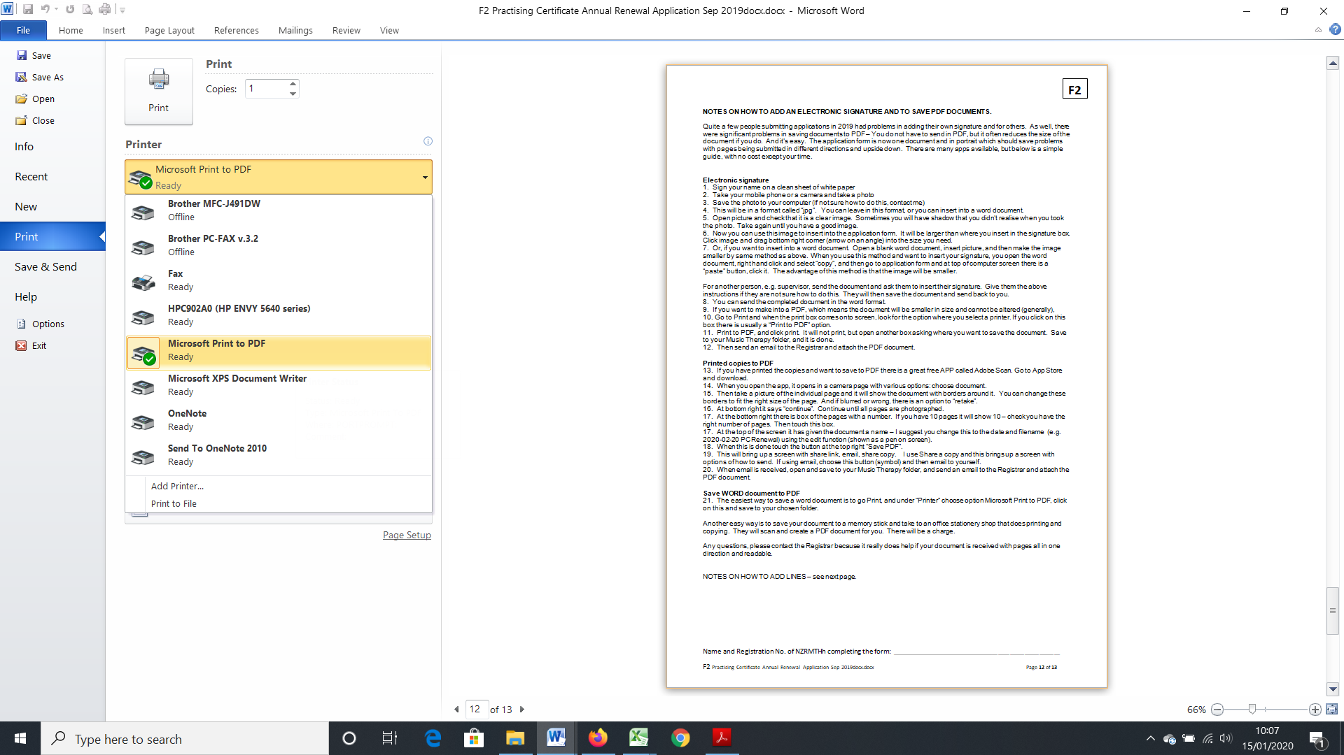

23. Another easy way is to save your document to a memory stick and take to an office stationery shop that does printing and copying. They will scan and create a PDF document for you. There will be a charge.

**HOW TO ADD LINES**

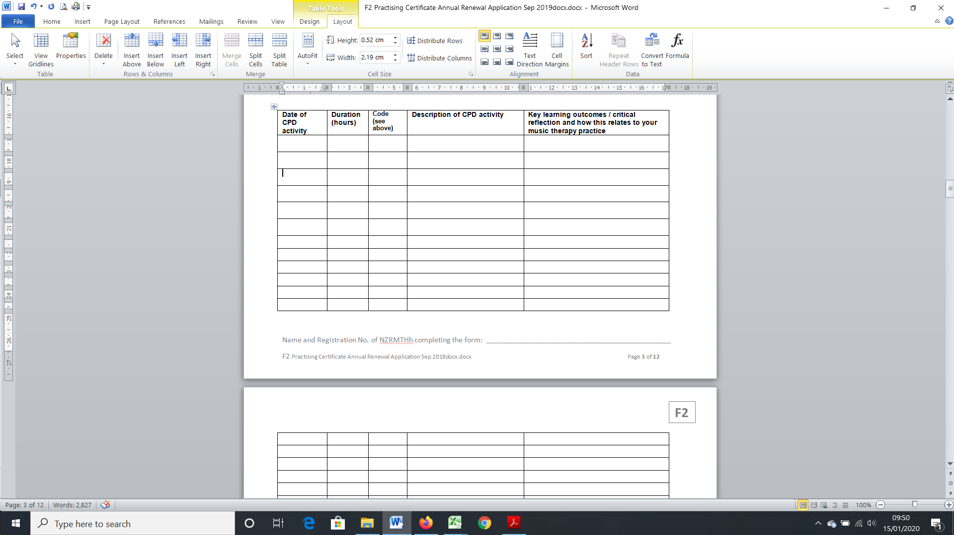

Put cursor on any line

Click on Layout at top

Click on Insert Above or Below

24. The same process applies to delete a line, if you wished to reduce the number of lines on a page.

Any questions, please contact the Registrar because it really does help if your document is received with pages all in one direction and readable.

Barbara Lewis, Registrar

[registrar@musictherapy.org.nz](mailto:registrar@musictherapy.org.nz) M: 027 7770228

NZ Music Therapy Registration Board