Book Review
Gordon-Flower, M. (2019). Arts Therapies with People with Physical Disabilities: An Archetypal Approach.
Jessica Kingsley Publishers.

Reviewer: Rebecca Travaglia
MMusTher, GradDipECE Teaching, BMus (Contemporary Rock), NZ RMTh
Private Practice, Oamaru

Citation
Travaglia, R. (2021). [Review of Arts Therapies with People with Physical Disabilities: An Archetypal Approach, by M. Gordon-Flower.] New Zealand Journal of Music Therapy, 19, 119-123. https://www.musictherapy.org.nz/journal/2021-2

Date published
December 2021

Marion Gordon-Flower's book, Arts Therapies with People with Physical Disabilities, is a descriptive resource that demonstrates how meaningful and beneficial art therapies can be for people living with mobility and communication challenges. The author is a registered Arts Therapist based in Auckland, New Zealand. She has worked for eight years in an arts therapy service management role in mental health. Her book illustrates the strengths of a holistic approach that embraces all aspects of the clients she works with. Having previously collaborated with a dance movement therapist (Travaglia & Treefoot, 2010), I was interested to review this book, to extend my knowledge of arts therapy approaches in Aotearoa New Zealand.
I believe that highlighting Aotearoa New Zealand’s bicultural values within a therapeutic context is vitally important. Indeed, the value of whanaungatanga (reciprocity and relationships) is embraced in Music Therapy New Zealand’s (2021) core values. This acknowledgement of biculturalism is evident in the book’s case studies, based on Gordon-Flower’s arts therapy practice.
This book offers a clear explanation of an archetypal approach and describes how “they provide opportunities for a form of liberation into unconscious creative processes” (Gordon-Flower, 2020, p.19). She draws on Jungian psychology to list archetypal concepts, including symbolic objects and shapes, mythological stories and creatures, narrative patterns, rituals, and spiritual notions. The universality of many of these symbols suggests that archetypal modes can be found across cultures. Descriptions of how to use archetypal approaches in therapeutic work were detailed and well referenced with extra resources (discussed below). As someone who has not used archetypal approaches in my own work, extra readings and detailed explanations of ways to use these approaches provided integral information to deepen my understanding.
The author’s clear writing style makes the book easy to dip in and out of. The book’s structure is clearly laid out, making it accessible for both beginning and experienced therapists. Psychologist and drama therapist Caroline Miller, whose own edited books include chapters by Gordon-Flower, highlights in the foreword how this book and the author’s therapeutic approach address a gap in the literature.
In each chapter Gordon-Flower focuses on different modalities, including individual and group art therapy, environmental sculpture, expressive dance movement, drama, and music. Each case study is written sensitively, narrating the unique therapeutic journey each client undertook. Observations and reflections within the narrative allow the reader to understand both the client’s progress and Gordon-Flower’s reasoning behind the strategies used. The detailed and in-depth case studies are interwoven with suggested practical strategies and interventions that readers can use in their own work.
Working as part of a multidisciplinary team, Gordon-Flower often touches on the importance of collaborative work and explores how arts therapists can work together and alongside other disciplines for the greater benefit of their clients. This focus on collaboration echoes the sentiments she expressed in her previously published description of the use of the 5-Pt Star Assessment Tool in evidence-based arts therapies practice (Gordon-Flower, 2014a, 2014b, 2016). Designed by Gordon-Flower, each of the tool’s domains has been translated into te reo Māori to encourage cross-cultural understanding of the therapeutic focus. She indicates that her tool is compatible with other health models, including Durie’s (1994) Te Whare Tapa Whā Māori model of health. This model was written from a Māori perspective for all New Zealanders and is widely applied in health and education contexts. Te Whare Tapa Whā is referenced significantly in Gordon-Flower’s use of music in multimodal work with a group of men, which focused on the Māori atua (gods).
Archetypal themes in Māori pūrākau (stories) are also embraced in a dance movement therapy group, where individual therapeutic goals are achieved through group support, reflecting the Māori value of collectivism. In two other case studies, spirituality is explored through the creation of sacred vessels, where Gordon-Flower shows sensitivity to clients expressing their own cultural and spiritual awareness through sculpture.
The practical strategies provided alongside the case studies include a rich selection of resources. Photographs, diagrams, and descriptions illustrate the range of resources utilised within the therapeutic process. The images were provided in both black and white within the text and a coloured insert. While these images provide a visual element to the text, I felt acutely aware of the limitations pictures have in conveying the significance and emotional energy attached to the work produced. Having said that, Gordon-Flower’s intricate descriptions of the therapeutic process aid in communicating this important element of the work.
I found the description of music approaches different to how a music therapist might describe their work. For example, Gordon-Flower provides lists of activities rather than microanalysis of the group’s musical interactions. This perhaps illustrates how a multimodal arts therapist will play to their strengths, using a variety of approaches but perhaps not have the depth of understanding of all art forms. Additionally, more recent research is available that could have been referenced to support the use of choirs in therapeutic work.
Within the case studies, Gordon-Flower acknowledges the challenges of working successfully and respectfully with her clients. These included accessibility of sessions and resources for those requiring physical assistance and collaborative care, sensitivity to subtle communication styles, and clear guidance for staff members who were assisting. These limitations required time and team discussion, reflecting the importance of building reciprocal and respectful relationships with other professionals working with our clients.
In the final chapter, the author offers insight into supervision within multidisciplinary teams, describing case scenarios where symbols and archetypal elements are used in guiding supervision. For example, the four elements (earth, wind, fire, water) are used in personal supervision to enable the team member to gain a different perspective and emotional detachment to allow conflict within the team to be resolved.
The multicultural approaches in the case studies particularly interested me as a Pākeha therapist and teacher in Aotearoa. When working multiculturally, there is a need for personal reflexivity, explicit sensitivity, knowledge and respect for how a client’s culture is represented within a therapeutic setting. Taking opportunities to consult with local iwi, Māori colleagues, our clients and their families will develop our understanding and knowledge of te ao Māori. Our multicultural nation is growing and our knowledge of cultures must also grow, as it plays such an important role in the development of cultural competence.
Gordon-Flower clearly demonstrates a commitment to biculturalism and shows how Māori cultural values can support and deepen therapeutic work. I was curious to know more about her own positionality. She acknowledges the support and guidance given to her for both tikanga and translations into te reo Māori. However, further explanation of her own level of knowledge and the consultation process could have been more transparent, to demonstrate her approach to using te ao Māori pūrākau in therapeutic work and to offer guidance to readers. It is sometimes unclear whether the themes and pūrākau chosen were client-led or therapist-led and whether the culture of the client dictated the appropriateness of this choice. For example, in the music chapter Gordon-Flower indicates that the clients embraced the opportunity to strengthen their Aotearoa New Zealand identity through engaging in Māori culture, but does not explain whether the clients themselves are Māori. Including a personal statement to explain her knowledge that goes beyond her position as a New Zealand multi-modal arts therapist, would provide the reader with further context.
Overall, this book was an interesting and thought-provoking read, offering plenty of practical resources for therapists to use in their own work. The clients described in the book range in age from young adults to older people, making it applicable for readers who work with a variety of age groups. The book embraces various creative arts approaches (music, art, dance and movement) so therapists from all branches of the creative arts may find this book interesting.

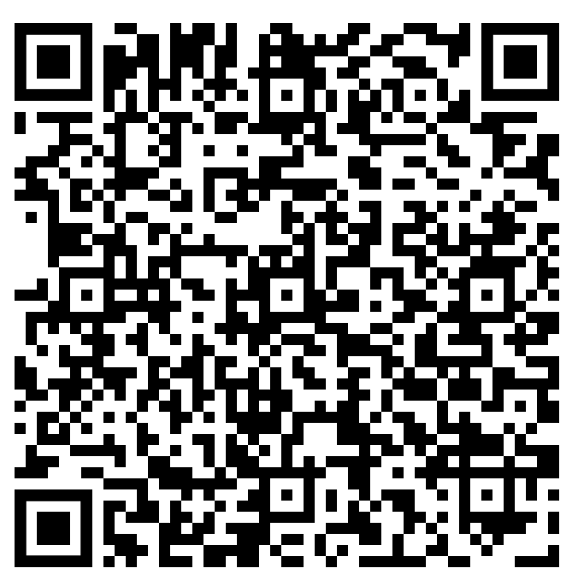
Link to Publisher’s Webpage
https://uk.jkp.com/collections/author-marion-gordon-flower-pid-205800

References
Durie, M. (1994). Whaiora: Maori health development. Oxford University Press.
Gordon-Flower, M. (2014a) In C. Miller (Ed.), Assessment and outcomes in the arts therapies: A person-centred approach (pp.104-119). Jessica Kingsley Publishers.
Gordon-Flower, M. (2014b). Nursing the wounded heart. In C. Miller (Ed.), Assessment and outcomes in the arts therapies: A person-centred approach (pp.33-53). Jessica Kingsley Publishers.
Gordon-Flower, M. (2016). Dances of paradox and role diffusion. In C. Miller (Ed.), Arts therapists in multidisciplinary settings: Working together for better outcomes (pp.68-82). Jessica Kingsley Publishers.
Music Therapy New Zealand. (2021). About music therapy. Retrieved December 13, 2021, from https://www.musictherapy.org.nz/about-mthnz
Travaglia, R. & Treefoot, A. (2010). Exploring the dance and music dialogue: Collaboration between music therapy and dance movement therapy in Aotearoa/New Zealand. New Zealand Journal of Music Therapy, 8, 34-58.

