# Resource Review

# Spragg, M. (2019). *We Can Play: Resource Book and Album.* Sounding Board Music Therapy.

### Reviewer: Fiona Hearn

MMusTher (Hons), BMus, NZ RMTh

Wellington Early Intervention Trust, The Swan Nest, and private practice

### Citation

Hearn, F. (2021). [Review of We Can Play, by M. Spragg.] New Zealand Journal of Music Therapy, 19, 11-15. <https://www.musictherapy.org.nz/journal/2021-2>

### Date Published

November 2021 (Early Online); December 2021 (NZJMT, 19)

*We Can Play* is an album and resource book written by New Zealand trained Registered Music Therapist Megan Spragg, now based in Melbourne, Australia. She is the founder and Director of Sounding Board Music Therapy Services.[1] I was excited to review this new resource, as I am a music therapist who trained in Wellington at a similar time, and we both work predominantly with children.

The resource’s 13 songs and activities were developed from material inspired by work with clients over several years. They encompass a range of goals, such as greeting others, sensory regulation, joint music-making, turn-taking, movement, vocalisation, and relaxation. Although no age range is specified, the illustrations and content suggest that it is primarily for young children.

The album’s spiral bound resource book is brightly illustrated, visually appealing, and easy to use. Lyrics and chords are provided for each song, along with the key, time signature, and suggested tempo. The book is well presented and includes descriptive material alongside each song, including intended goals and ways of using the songs in groups or individual settings. A list of “Points to Notice” supports practitioners to anticipate how children may respond during an activity. Some of the songs have “Questions for your group members”, designed to help clients reflect on their emotional responses to the experience.

The accompanying audio recordings offer a wide range of musical styles, tempi, keys, and moods. The songs range from happy upbeat songs designed to engage and stimulate, to more gentle tracks with aims of relaxation and reducing anxiety. A variety of instruments and vocal harmonies feature on the professionally recorded tracks, providing a strong accompaniment for people who may not have the musical skills or confidence to play the songs live.

Although the digital tracks could be played immediately as a ready-to-use activity, I have found the fullest therapeutic value is gained when the songs are sung and played live with instruments, and adapted to the culture and context of the clients I work with. The songs are easy to learn, memorise and adapt to different contexts, due to their simple yet effective chord progressions and use of repetition. I adapted some of the songs for use in early intervention with preschool children with learning support needs and their whānau. The simple melody lines offered opportunities for easy lyric substitution and adaptation to include greetings in te reo Māori, reflecting our Aotearoa New Zealand context.

The songs I have introduced to my group and individual sessions have been positively received by clients, whānau, and the transdisciplinary team. My favourite songs from the album include Let’s Say Hello Today, Squeeze My Hands, and Drumming Blues. Squeeze My Hands and Drumming Blues have a timeless feel and would also be suitable for older children, adolescents, or adults with learning support needs. I have found Squeeze My Hands to be beneficial both as a warm-up activity and as a means of facilitating sensory regulation for clients who seek proprioceptive input. Drumming Blues uses a 12-bar blues structure and is a fun group activity – I have adapted this to encourage individuals to have a solo turn before handing their drum sticks to another child. The song provides a predictable musical format for clients to develop skills for self-expression. The structure of the song offers flexibility to match the tempo, dynamics, and style of each child’s individual improvisation. I have found this song useful when supporting children whose playing may be either loud and expressive, or tentative and needing gentle encouragement.

*We Can Play* is available to purchase either digitally or as a CD and hard copy resource book from Sounding Board Music Therapy. The website offers options to purchase and download individual songs, which come with a one-page pdf chord and lyric chart and notes on how to use the song. The songs are also available on Google Play, iTunes, YouTube, and Amazon Music.

The book contains minor editorial errors: a typo in the introduction, some overcapitalisation of text, and inconsistent punctuation of bulleted lists. However, these are minor details that do not detract from the overall high quality of the resource. A useful addition to the album would have been a song targeting identification and expression of emotions, as I find this to be an important area of focus when working with young children.

I recommend this resource to Registered Music Therapists, music therapy students, early childhood and school teachers, carers, whānau, and anyone working with children. People working with older children, adolescents, or adults with learning support needs would also find it helpful as a general resource. The collection provides fresh ideas for those needing new inspiration and encompasses a good range of musical styles and suggested goals. I hope that Megan Spragg continues to produce such high quality albums and resources for therapeutic and whānau use.

Megan Spragg’s album adds to a growing collection of resources by New Zealand Registered Music Therapists. Other publications include *Music Therapy Songs for Special Kids* (Stelino, 2015, reviewed by Churchill, 2016); *Joan’s Songs: A Collection of Music Therapy Songs* (Webster, 2015, reviewed by Willis, 2016); and *Songs from NZ Music Therapy* (Talmage, 2013, reviewed by Hoskyns 2015). Several songs by New Zealand Registered Music Therapists have also been published over the years (Johnson & Rickson, 2018; Krout, 2003; Music Therapy New Zealand, Auckland Regional Group, 2016; Scoones, 2012, 2014, 2019; Talmage et al., 2013; Talmage et al, 2020). Several music therapists – Heather Fletcher, Sidharth Pagad, Andrea Robinson, Alison Talmage, and John-Paul Young – also contributed to an anthology published by the Song Leaders Network Aotearoa (Shortis & Raphael, 2018). Another song of particular significance to the music therapy community is Te Manaaroha Rollo’s waiata, *Āio Mauritau Āio*, gifted to Te Kōkī – New Zealand School of Music (Rollo, 2013a, 2013b) and recorded by a virtual choir of New Zealand music therapists to celebrate Music Therapy Week 2020 (Rollo, 2020).

Music therapists improvise and create songs in our practice, but we publish less often! I hope that more music therapists, both local and international, will be inspired to explore this resource and to produce further publications specifically for our Aotearoa New Zealand context.

## References

Churchill, V. (2016). [Review of Music therapy songs for special kids, by A. Stelino.] New Zealand Journal of Music Therapy, 14, 6-29. <https://www.musictherapy.org.nz/journal/2016-2>

Hoskyns, S. (2015). [Review of Songs from NZ music therapy, by A. Talmage (Ed.).] New Zealand Journal of Music Therapy, 13, 59-62

Krout, R. (2003). Growth, challenge and change: The continuing journey of Music Therapy Aotearoa through community, metaphor and song. New Zealand Journal of Music Therapy, 1, 6-19.

Johnson, E., & Rickson, D. (2018). Songwriting with adolescents who have mental health difficulties: One music therapy student’s experience. New Zealand Journal of Music Therapy, 16, 115-137. <https://www.musictherapy.org.nz/journal/2018-2>

Music Therapy New Zealand, Auckland Regional Group (2016). Let’s celebrate music therapy! New Zealand Journal of Music Therapy, 14, 8-9. <https://www.musictherapy.org.nz/journal/2016-2>

Rollo, T. (2013a). Āio Mauritau Āio. New Zealand Journal of Music Therapy, 11, 6-7.

Rollo, T. (2013b, November 24). Mā te wai ka piki ake te hauora (Through water, music and spiritual connection brings about human ‘well being’) [Paper presentation]. Linking Cultures: NZSM Music Therapy Conference, Wellington, New Zealand. Vimeo. https://vimeo.com/80754843

Rollo, T. (2020). Āio mauritau āio [Song recorded by R. Solly and Registered Music Therapists]. YouTube. <https://youtu.be/Y9YYQOkA1YQ>

Scoones, R. (2012). Let’s go home [CD]. <https://russellscoones.com/albums>

Scoones, R. (2014). Hey little moon [CD]. <https://russellscoones.com/albums>

Scoones, R. (2019). Hang out together [CD]. <https://russellscoones.com/albums>

Shortis, C., & Raphael, J. (Eds.). Songs from the land: Original songs by New Zealand song leaders. Song Leaders Network Aotearoa.

Stelino, A. (2015). Music therapy songs for special kids [CD]. Ahjay Stelino. <https://ahjaystelino.com>

Talmage, A. (Ed.). (2013). Songs from NZ music therapy. Raukatauri Music Therapy Centre and Music Therapy New Zealand.

Talmage, A. (2020). Log on and sing. In A. Talmage, M.B.C. Clulee, H. Cho, M. Glass, J. Gordon, S. Hoskyns, B.J. Hunt, A.A.Y. Jeong, L. Johns, J.C. Kong, E. Langlois Hunt, E. Matthews, D. Rickson, C. Rieglhaupt Landreani, S. Sabri, & R. Solly, Music therapy in a time of pandemic: Experiences of musicking, telehealth, and resource-oriented practice during COVID-19 in Aotearoa New Zealand. New Zealand Journal of Music Therapy, 18, 50-54. <https://www.musictherapy.org.nz/journal/2020-2>

Talmage, A., Ludlam, S., Leão, S, Fogg-Rogers, L. & Purdy, S. (2013). Leading the CeleBRation Choir: The Choral Singing Therapy protocol and the role of the music therapist in a social singing group for adults with neurological conditions. New Zealand Journal of Music Therapy, 11, 7-50.

Webster, J. (2015). Joan’s songs: A collection of music therapy songs by Joan Webster. Music Therapy New Zealand.

Willis, M. (2015). [Review of Joan’s songs: A collection of music therapy songs by J. Webster.] New Zealand Journal of Music Therapy, 14, 192-195.

### Link to Publisher’s Webpage

<https://www.soundingboardmusictherapy.com>

**[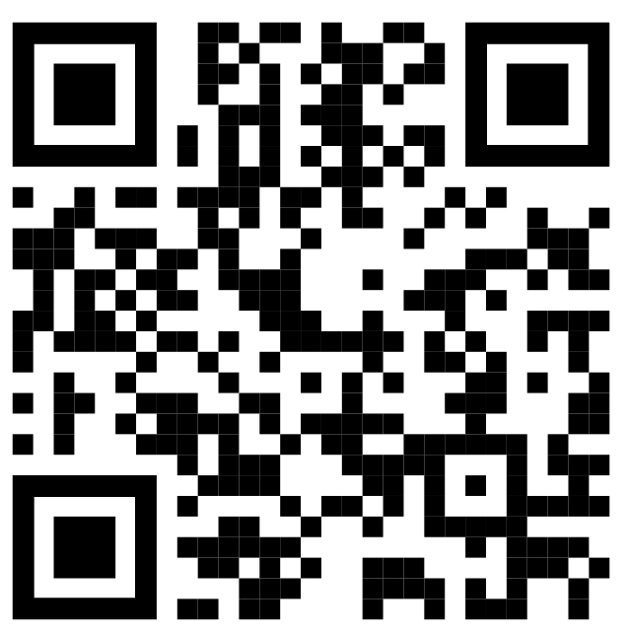](https://www.soundingboardmusictherapy.com/)**

1. <https://www.soundingboardmusictherapy.com>